Increasing Literacy Achievement and Learner Confidence in

Remote Rural Schools in British Columbia

The intent of the project is to enhance the professional capacities of teachers in rural and remote schools in British Columbia with high percentages of Aboriginal learners in support of increased literacy achievement for K-7 students. The video provides teachers and project coaches with vivid working examples of core instructional strategies that can advance student literacy and cultural understanding, particularly the use of rich Aboriginal texts and formative assessment strategies. This literacy initiative/research project is funded by British Columbia's Ministry of Education.

Video Sequences At-a-Glance
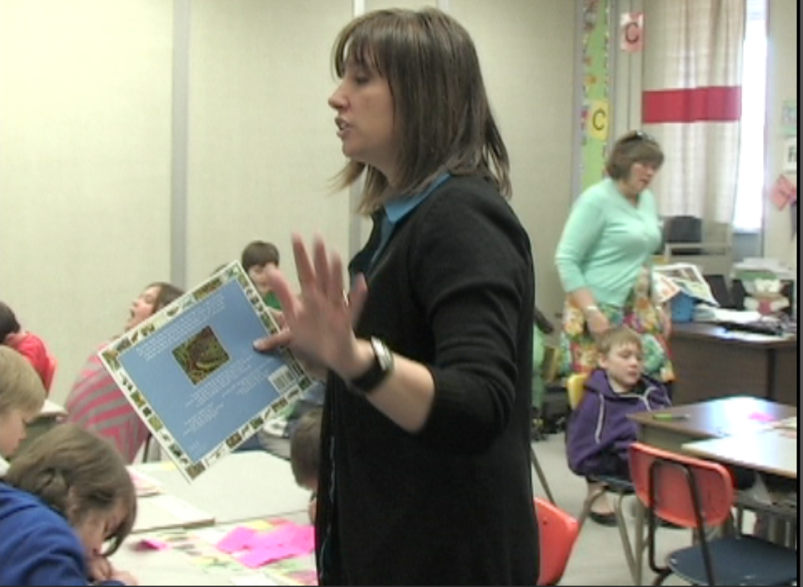
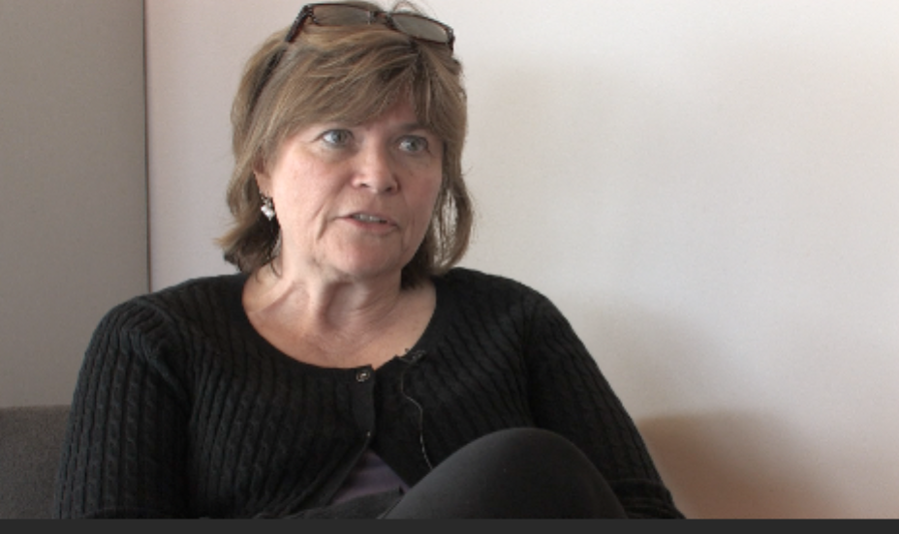
Colleen Gurney, classroom teacher at Glenview Elementary School in Prince George School District, teams with Deborah Koehn, former teacher at Glenview and a literacy coach in the project, in this lesson series that demonstrates powerful teaching and learning principles. Our goal is to illustrate exemplary teaching that supports both literacy learning and understanding of Aboriginal ways of knowing and learning.

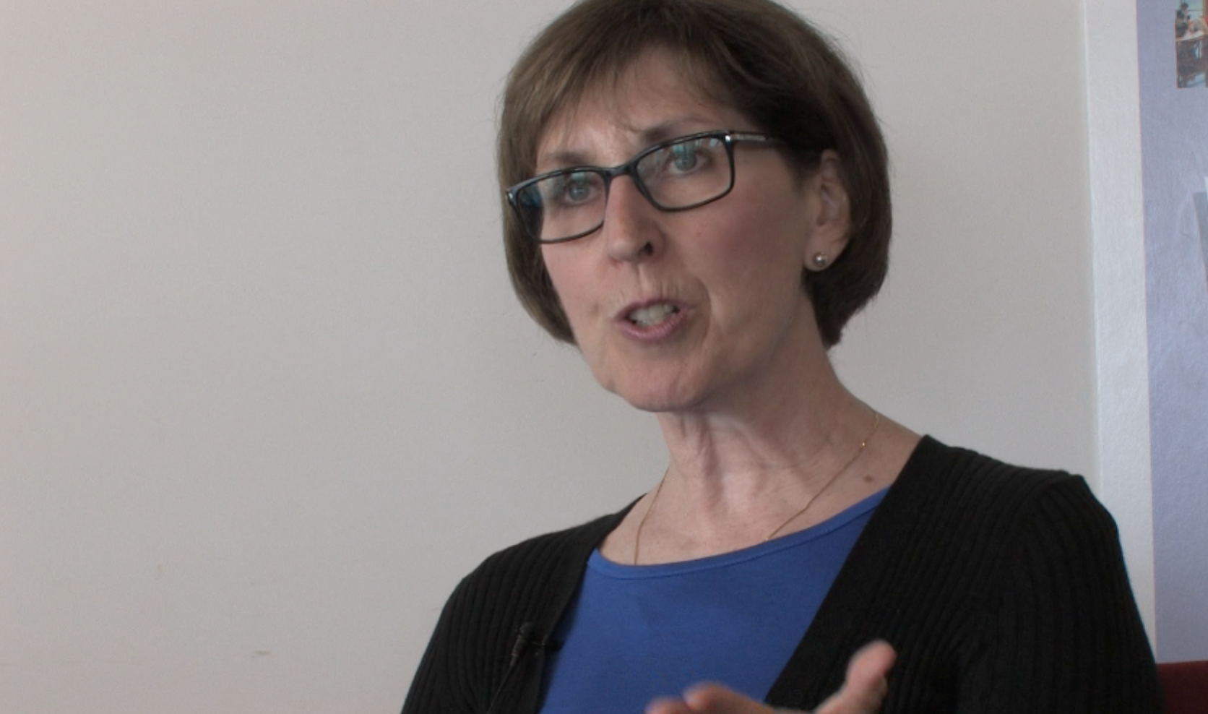
Inspiring too, is the depth of student ownership of their personal learning as reflected in their mindful responses to inquiry questions, supported by their sophisticated grasp of meta-cognition (their high capacity to explain the learning strategies they are applying). Rich examples of Assessment for Learning are found in students’ clear articulation of specific assessment criteria and related learning strategies that guide their learning.

Referencing the classroom sequences are insights from both Deborah Koehn and colleague Frances Roch, whose roles as literacy coaches, finds them providing active support for growing literacy practices and building vibrant professional learning communities.

Guide to the Video Sequences
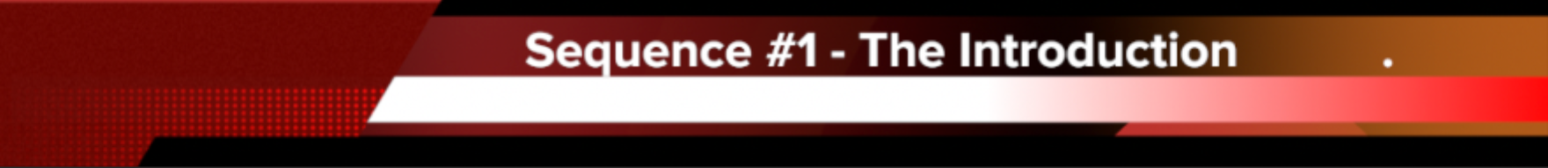
Sequence #1 – Intro with Deborah Koehn
https://vimeo.com/82054745 4 Min
In the lesson leading up to this video sequence, Deb worked with the class in the study of maps of Prince George, examining the river systems, industry and businesses and the health of the river. Students discussed how the First Peoples’ Principles of Learning connected to their understanding of Earth Day and to their community.
In this lesson sequence, Deborah presents the introduction. As project coach and a teacher with whom most of the students have previously worked, Deborah teams with Colleen for the whole lesson series. In this introduction, she reviews students’ prior knowledge and big ideas discussed in the previous lesson. After refreshing students’ learning regarding important background knowledge, Deb reviews the First Peoples’ Principles of Learning while emphasizing the key literacy skills to be learned. Last, she outlines the main learning intention related to sharing personal thinking about Earth Day and personal connections to the land, then hands the lesson over to Colleen.

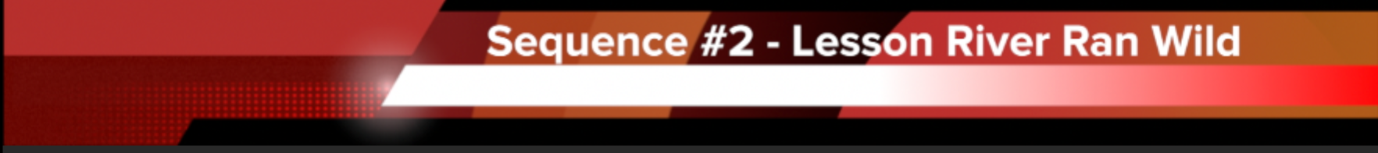
Sequence #2 – The Lesson River Ran Wild
- with Colleen Gurney 13 min
http://vimeo.com/81864897
This sequence shows excerpts from the lesson beginning with Colleen reading the first part of the story. Colleen embeds group and individual thinking tasks ensuring that the students are actively engaged at regular intervals: She asks the students to deepen their learning by making connections to the story; to identify the big ideas, and to discuss their ideas with peers. Equally important to the questions she asks are her affirming and extending responses to the student ideas. Active student participation time is deliberately framed around clear purpose. In this sequence, for example, at an early stage of the reading Colleen asks groups to discuss “What connections can you make between the land and Earth Day?” and later, asks about connections made with their new learning and the map of their own home rivers. Through these group talk techniques, students slowly construct and clarify their ideas and personal perspectives regarding the stewardship of the rivers and begin to make connections between the story and their personal experiences, as well as develop confidence in expressing emerging ideas with increased clarity.
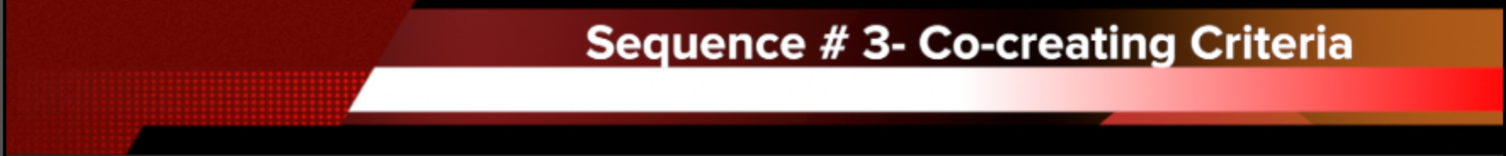
Sequence # 3 – Co-creating with Class the
Criteria for their Writing Response 6 min
http://vimeo.com/81866560
In this sequence, the students are asked to contribute to the construction of a detailed list of criteria that will be summarized. Copies are given to each student to clip on the top of their notebooks to help guide them in their writing. The list developed in this lesson builds on criteria that have been developed over the three months since September. To engender a degree of student choice, students are asked to attend to two ‘must haves’ in the criteria, then work toward another two of their choice. This helps students to lead their own learning.
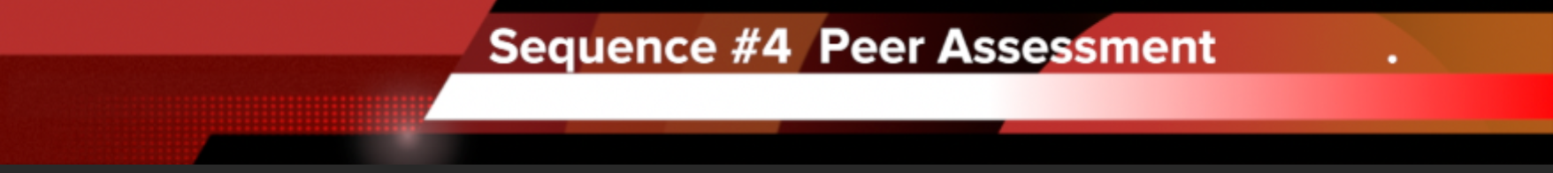
Sequence # 4 – Co-creating with Class
the Criteria for Peer Assessment 9 min
http://vimeo.com/81867643
This sequence begins with Deborah reviewing the learning from the previous lesson, highlighting the learning intentions and recapping the criteria that Colleen has developed with the class for their writing assignment – now completed. Colleen then asks the class the question What does good feedback look like? Together they build the specific steps and vivid examples of how to give and receive constructive feedback with partners related to each criterion. The purpose is to provide their partner with clear information from which they can make their final edits. The students are then paired up and begin the process. The video shows how the students follow the defined structure to carry out this challenging task.
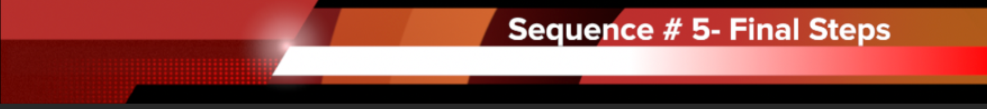
Sequence #5 – Final Steps of Process - Students use feedback to complete edits 3 min
http://vimeo.com/81886884

In this last and final sequence Colleen explains how students are to do their last edits, using colour to distinguish the changes made from original work. She ends with a quick recap of the specific pieces of the project that the students will hand in for teacher assessment.

